ELB:

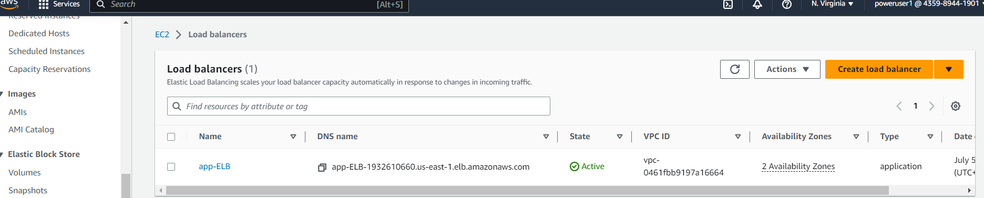

EC2 instance:

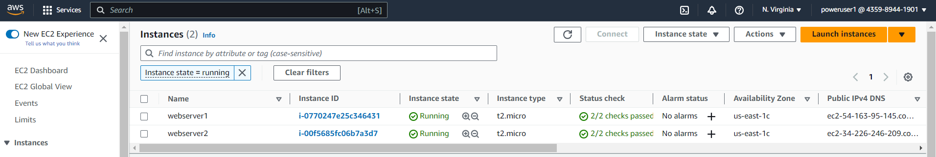

Created Target Group

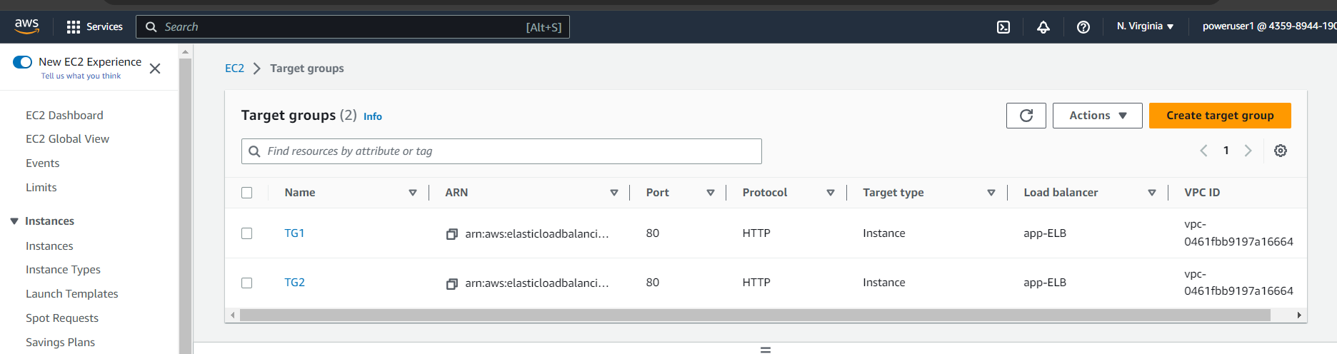

Output Traffic from ELB:

